**Project Design Phase**

**Problem – Solution Fit Template**

|  |  |
| --- | --- |
| Date | 27 June 2025 |
| Team ID | LTVIP2025TMID59193 |
| Project Name | SmartSDLC – AI-Enhanced Software Development Lifecycle |
| Maximum Marks | 2 Marks |

**Problem – Solution Fit Template:**

The Problem-Solution Fit simply means that you have found a problem with your customer and that the solution you have realized for it actually solves the customer’s problem. It helps entrepreneurs, marketers and corporate innovators identify behavioral patterns and recognize what would work and why

**Problem**

Software development teams, especially in startups and fast-paced environments, face constant bottlenecks and inefficiencies in the Software Development Life Cycle (SDLC). Common issues include:

* Time-consuming manual requirement analysis and classification
* Delay in bug detection and fixing
* Redundant and inconsistent code generation
* Lack of integration between Continuous Integration (CI) tools and intelligent assistance
* Inability to respond quickly to changes or stakeholder feedback

These problems result in longer development cycles, higher costs, and lower software quality, directly impacting product delivery and customer satisfaction.

**Solution:**

* AI-driven Requirement Classifier: Automatically identifies and classifies software requirements (functional, non-functional, UI, etc.)
* Bug Fixer AI: Instantly detects and suggests fixes for common code bugs
* Code Generator: Generates clean, starter code from natural language requirements
* Seamless CI Integration: Works with CI pipelines to provide real-time intelligence and updates

**Template:**

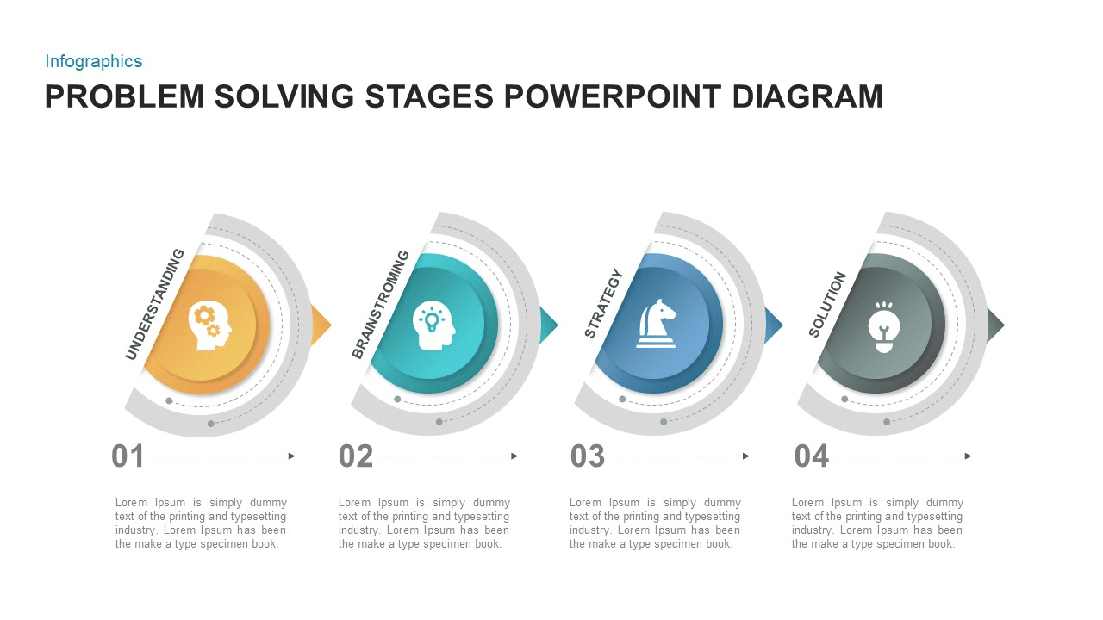

**Reference:**

**<https://slidebazaar.com/wp-content/uploads/2021/09/4-step-diagram.jpg>**